Getting Down to Basics: Examining Language and Understandings that Support the Creation of Equitable and Inclusive Workspaces

Common Language

Racial competence, as defined by Dr. Ali Michael in Raising Race Questions: Whiteness and Inquiry in Education (2015), is having the skills and confidence to engage in healthy and reciprocal cross-racial relationships; to recognize and honor difference without judgment; to notice and analyze racial dynamics as they occur; to confront racism at the individual, group, and systems level; to cultivate support mechanisms for continuing to be involved in antiracist practice even when it is discouraging or conflictual; to speak one’s mind and be open to feedback on one’s ideas; to ask for feedback about one’s ideas and work; and to raise race questions about oneself and one’s practice.

Glossary -- Racial Equity Resource Guide -- Kellogg Foundation

Tools / Strategies to Understand and Mitigate Implicit Bias

25 Mini-Films for Exploring Race, Bias and Identity -- New York Times
Bias Cleanse -- MTV
Check Our Bias to Wreck Our Bias -- New York Times
Codeswitch: A Lesson in How to Overcome Implicit Bias -- NPR
Implicit Association Test -- Project Implicit
Implicit Bias -- UCLA’s Office of Equity, Diversity and Inclusion
Implicit Bias, Lifelong Impact -- Kirwan Institute for the Study of Race and Ethnicity
Interview with Unconscious Bias Expert Mahzarin Banaji
Mind Bugs -- Mahzarin R. Banaji at TEDxBari
Race in the Academy with Dr. Ali Michael from UPenn
Test Yourself for Hidden Bias -- Teaching Tolerance

Reflection Resources for Self and Workspace / Classroom to Facilitate Equity and Inclusion

“Start from the premise that, of course, you've been impacted by these forces. There's no way that I wasn't impacted by the forces of racism in a country in which it's embedded and infused. And so just start there. And then try to figure out, OK, how have those forces shaped me and how are they manifested in my life and my relationship. That's a very different question. That's a question of how rather than if I've been impacted.” from Robin DiAngelo on White People’s Fragility -- NPR

21-Day Racial Equity Habit Building Challenge -- Debby Irving

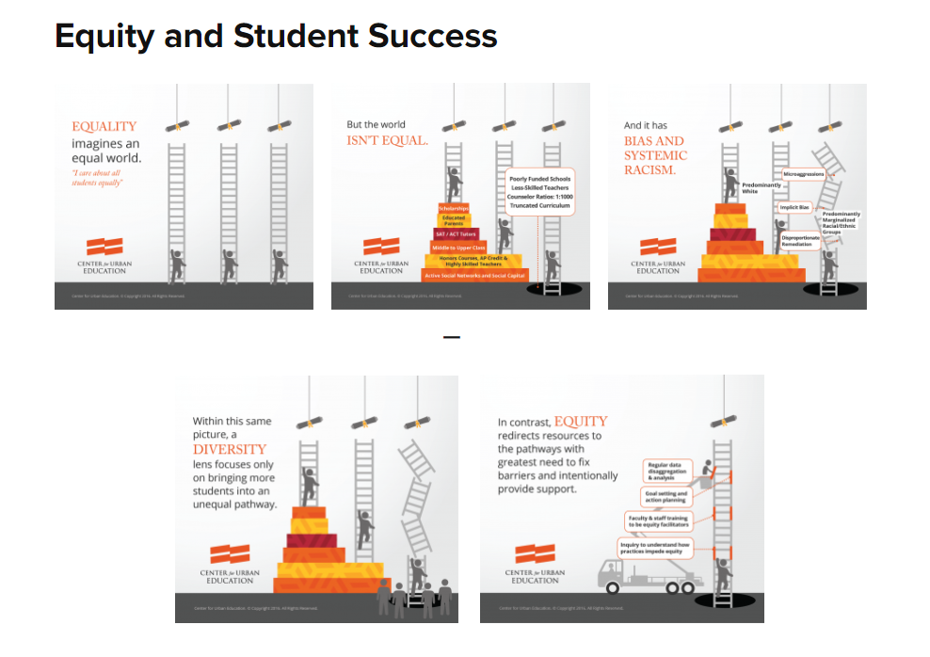
Equity and Student Success (see above image ) USC Center for Urban Education
Equity Mindedness USC Center for Urban Education

How Companies Can Identify Racial and Gender Bias in Their Customer Service -- Harvard Business Review, May 2018

Inclusive Teaching Strategies: Reflecting on Your Practice -- Center for Research on Learning and Teaching at University of Michigan

“OK, I Get It! Now Tell Me How to Do It!”: Why We Can’t Just Tell You How to Do Critical Multicultural Education (2010) --Robin DiAngelo and Ozlem Sensoy

For Further Reflection -- Are there any patterns?

Do you respond similarly or differently to colleagues or students of different backgrounds when they come to you with similar or identical concerns?

If you look at your email history, do you communicate more abruptly with some colleagues / students than others? Does it take you longer to reply to certain individuals than others?

Are there patterns in the folks to whom you give the benefit of the doubt?

When you plan a meeting or office hours, whose schedules do you take into consideration when deciding which times are best?

Is there a pattern in students’ grades / employees’ evaluations based on any identity?

Who are the folks in your friend group, on social media, in your office?

Do you ever “forget” to include someone in a meeting or gathering? Is there a pattern of whose is forgotten or left off of the list?

What data can you collect around what it means to show up as a leader / colleague / boss of your race? How do you show up?

When you plan classes and meetings, do you take into account various learning styles?

