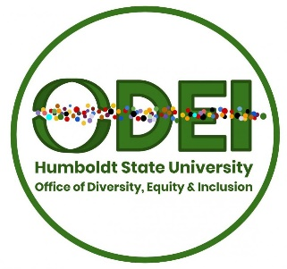
Diversity, Equity and Inclusion Council (DEIC)
AGENDA

April 24, 2019
Library Fishbowl
11-11:05 a.m. Welcome

11:06-11:15 a.m. Updates
- Outcome of Equity Arcata presentation at Senate, Tuesday, April 2nd
- Equity Advocate Initiative – faculty searches

11:16-11:40 a.m. The Brain – Mapping HSU’s Equity Efforts – Cassaundra Caudillo

11:41-12:50 a.m. Ongoing Conversations
- Timeline for Diversity, Equity and Inclusion Strategic Action Plan
- Defining what Diversity, Equity and Inclusion means to HSU – Mission, Vision, Values

12:51-1:00 p.m. DEI Related News and Events
- Alliance of Hispanic Serving Institution Educators (AHSIE) conference: Building an HSI Brand: How Marketing Can Support Institutional HSI Visibility and Reputation
- Dr. Gina Garcia of the University of Pittsburgh will be visiting on May 2nd and giving a keynote presentation from 11 am- 1pm at the KBR on the topic of “Becoming Hispanic-Serving Institutions.” Her book entitled, Becoming Hispanic-Serving Institutions: Opportunities for Colleges and Universities (Reforming Higher Education: Innovation and the Public Good) is now available.

******Next Meeting, May 22, 2019
******Summer Meetings?

